Spain’s Electricity Price Analysis



Electricity is a basic human in need and with increasing digitization, the demand for electricity as a commodity is exponentially increasing. Hence it is imperative that energy be made available to people at as low a cost as possible. This is easier said than done however. Electricity price is primarily a function of load, demand and a host of other dynamic factors. This can cause the price of electricity to fluctuate widely. Hence there is a need for a reliable forecasting model that can predict the price. Such a model can be helpful to utilities and consumers to schedule their energy consumption to a great extent.

Objective

The goal of this project is to analyze the hourly energy data along with the hourly weather data for 5 major cities in Spain- Barcelona, Madrid, Seville, Valencia and Bilbao and eventually predict the price of energy for the next hour as a function of the previous prices and weather data.

Who Benefits?

Being able to predict the price of electricity can help utilities gauge what the demand is going to be at certain times. It can help policy makers come up with incentives and ideas to help subsidize prices and keep them more affordable for the public.

Knowing the price of electricity beforehand, can help consumers schedule their daily energy consumption. This is especially useful in areas where utilities set a dynamic price. Household consumers can schedule activities such as washing and dishwashing during times of low demand and hence lower prices.

Data Source

The data has been sourced from Kaggle -

https://www.kaggle.com/nicholasjhana/energy-consumption-generation-prices-and-weather

The dataset has two .csv files which contain hourly information about the weather and electricity generation in Spain from January 2015- December 2019. In particular:
'weather_features.csv': This dataset details the hourly information about the weather conditions such as - wind speed, temperature, humidity, rainfall of 5 major cities in Spain namely - Barcelona, Bilbao, Madrid, Seville and Valencia.
'energy_dataset.csv': This dataset contains hourly information about the generation of energy in Spain. In particular, it details the amount of electricity generated by the various energy sources - fossil fuels, coal, wind energy and solar, as well as about the total load (energy demand) of the national grid and the price of energy (€/MWh). Note: Since the generation of each energy type is in MW and the time-series contains hourly info, the value of each cell represents MWh (Megawatt hours).

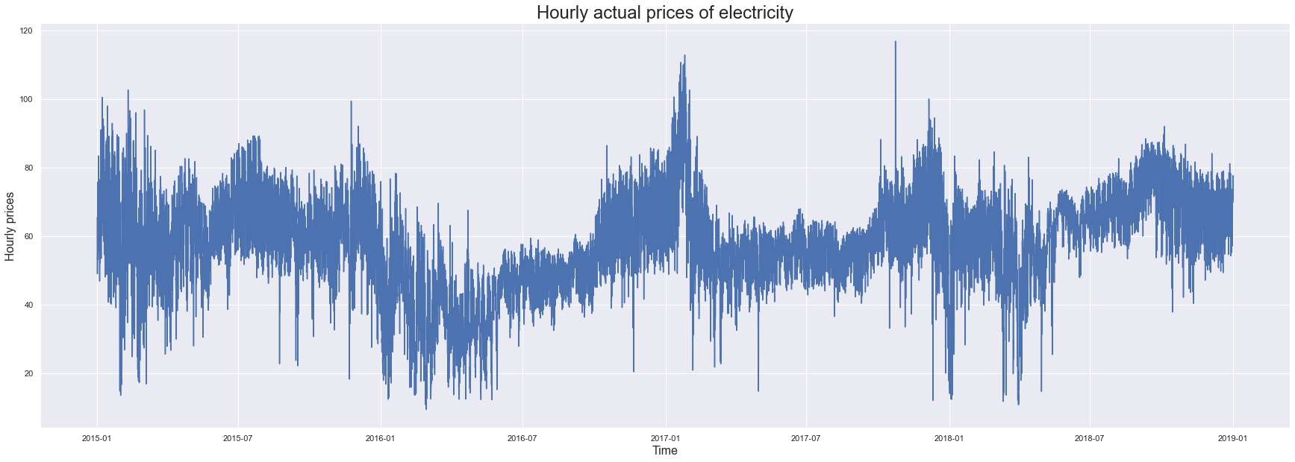

Lets get some insights!
Given that we are developing models for predicting the price of electricity at a specific time, we will model the effect of other features such as load, generation and weather data on the price. Before we do that let’s explore some of the features.

Actual load for two weeks
Energy demand is one of the key drivers of energy price and we start by looking at the actual load for a sample two week window.

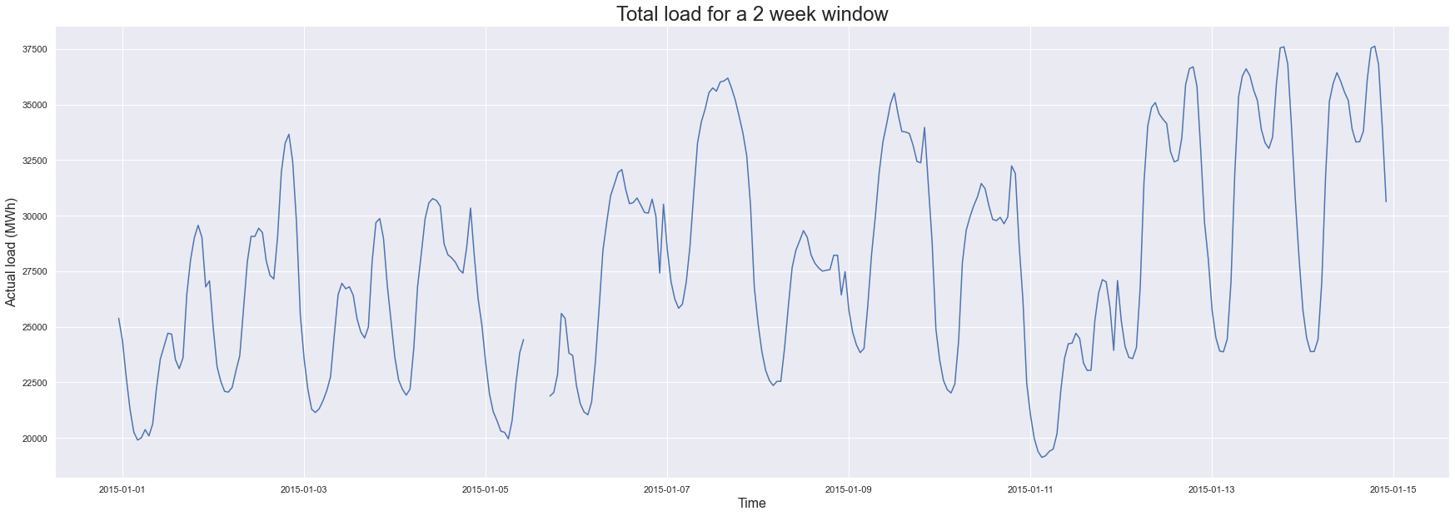
We notice a break in the actual load values here which we interpolate based on previous values. In general we observe a pattern in load variation every day and even intra day.

Weather Features
Supplementary features such as the weather can have an impact on the energy price. For example on a hot day - turning on coolers and air conditioners can increase the load and hence the demand. This can cause an increase in price if there isn't enough supply. Likewise higher than normal wind chill or lower temperatures can indicate cold weather conditions increasing the need for heat, which can again drive the price. Below we analyze the wind speed, pressure information and rain information for specific cities.

Wind Speed
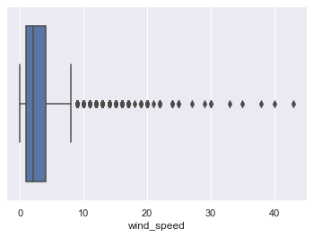

The image above shows the hourly wind speed information for all of the 5 cities from the year 2015 through 2019. While we notice some high values a bulk of them lie in the range of 0 to 10 m/s.

Pressure
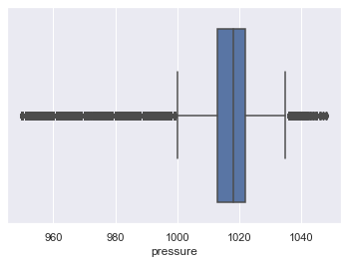

Likewise we see a bulk of the pressures in the range of 1000 to 1035 HPa.

Monthly electricity price with one year lagged
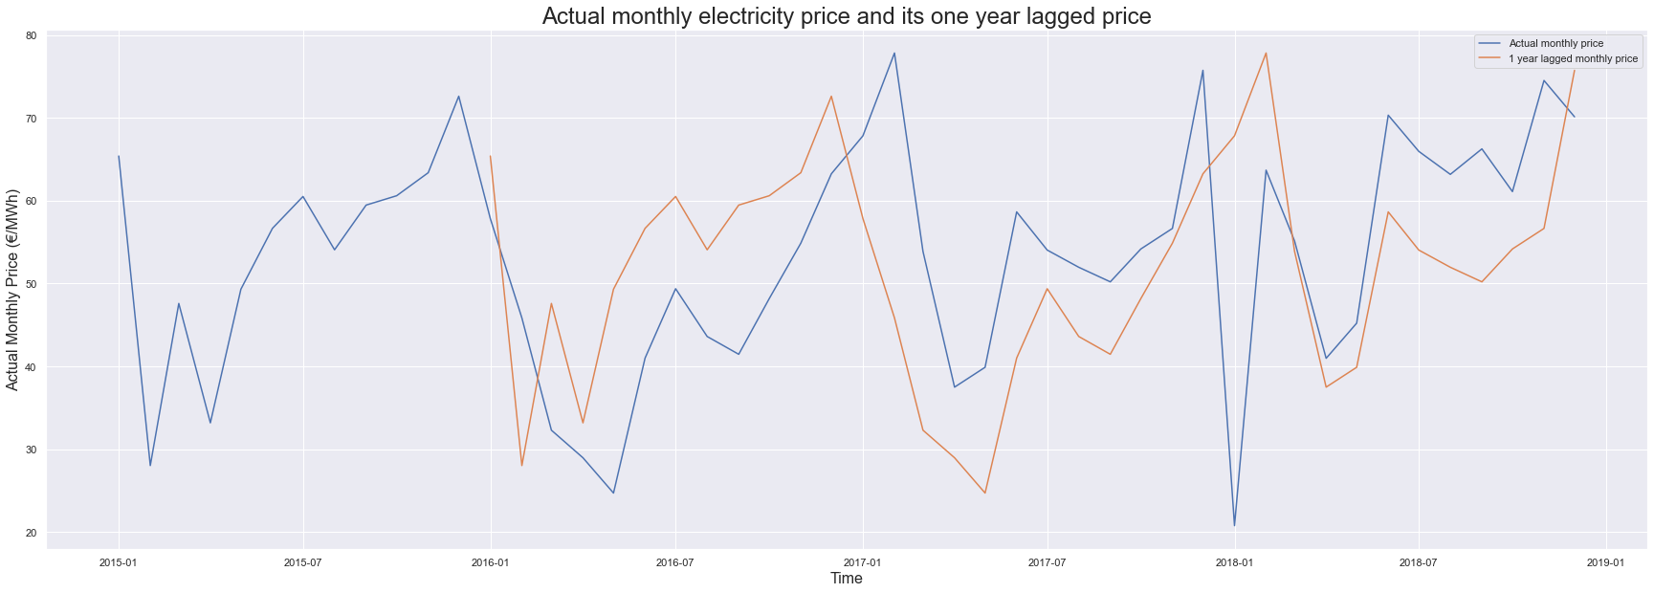

We see a seasonality in price even after shifting the prices by a year and comparing them with the actual prices at the time. This implies a pattern which is the motivation behind performing a test to check for stationarity of the time series. This check is necessary in order to make sure we feed in the right kind of model into our ML models.

Actual hourly price for a two week window
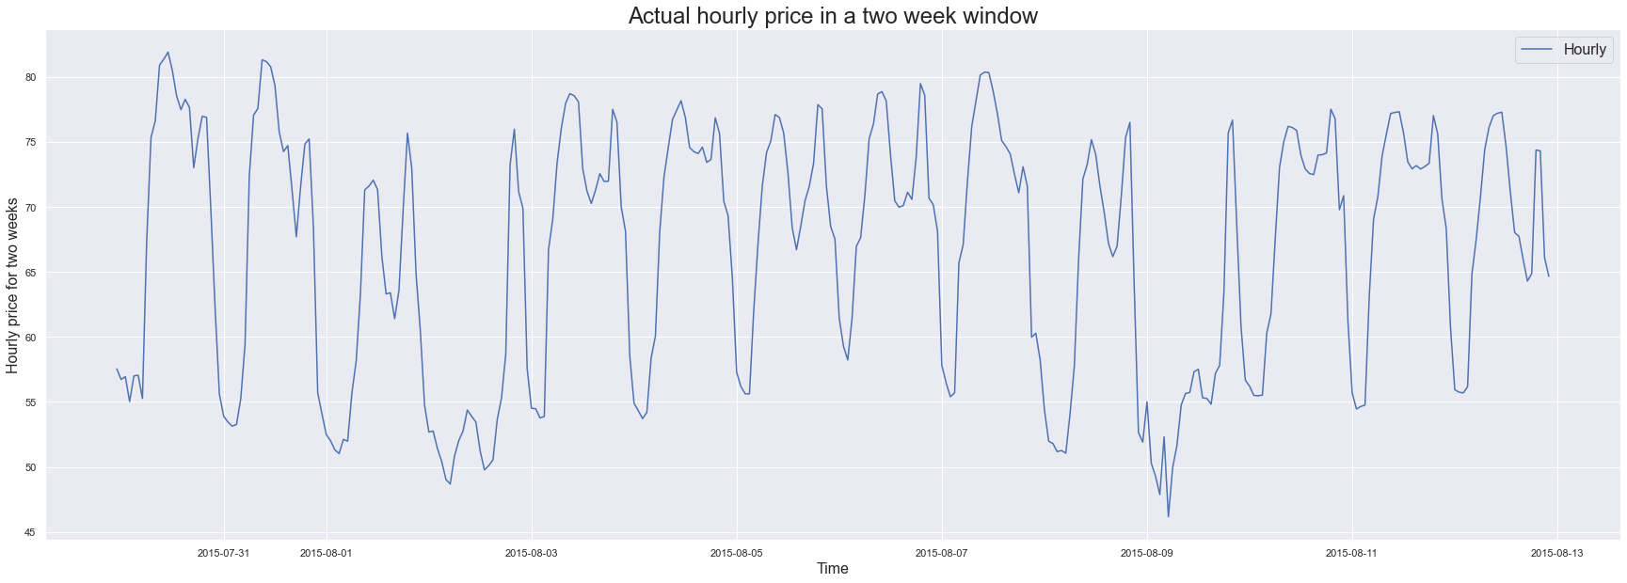
Not only is there a pattern in the monthly price, we notice a pattern in the daily price variation as well. This makes sense if we compare it to the actual load for a two week window. When the demand is high, so is the price of electricity.

Model Selection
As a part of the analysis done here there are 3 models of interest.

- Auto Regressive model
- Univariate Stacked LSTM
- Multivariate LSTM

Auto Regressive Model
We start by looking at the ACF and PACF plots to see how many previous time points we can consider to build the ARIMA model.

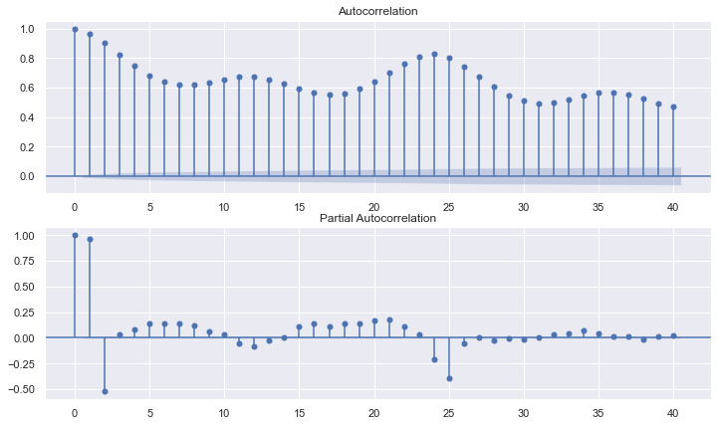

The PACF shows that upto 2 previous time points affect the current price. We use this as a fact to build an ARIMA model with p = 2, d = 0, q = 0.

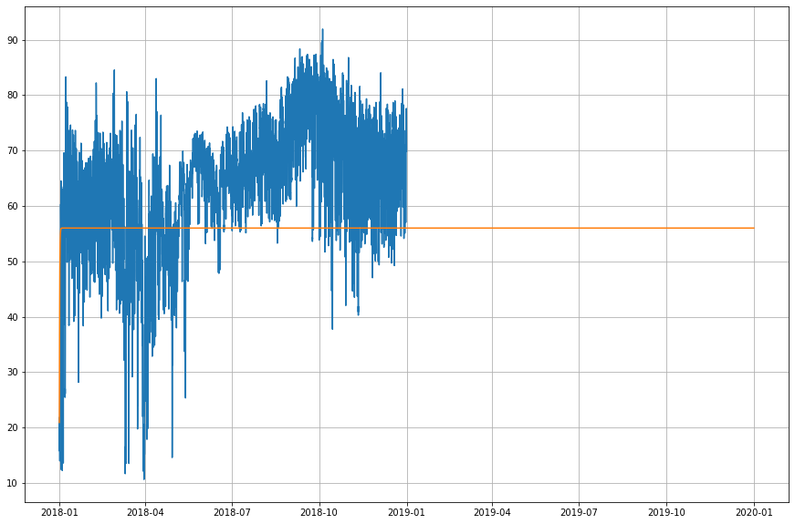

The above model is able to give us a price forecast depicted by the orange line whereas the plot in blue os the actual value. The above model is able to predict the price with an average margin of error of 2.66 Euro / MWh.

2 ) Univariate LSTM model
The stacked LSTM model is a deep learning model developed to predict a value in the time series. This model is univariate as it considers only the previous price points to predict the current price. Specifically we consider the price points for the last 12 hours to predict the current price.

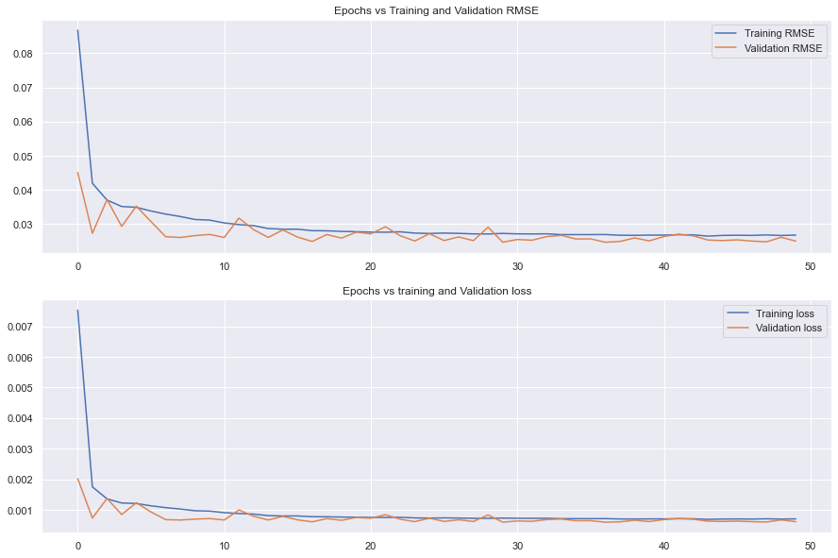

We notice that after the 10th test run on the time points the Root mean square error tends to normalize in the 0.02 - 0.03 window.

On calculating the error margin for the actual price vs the predicted price we get a value of 2.68 Euro / MWh.

3) Multivariate Stacked LSTM model

This model considers other features in the dataset such as the weather, load, generation. There are a total of 66 features between the two datasets. Hence we do a Principal Component Analysis to see how many components account for upto 80% of the variance.

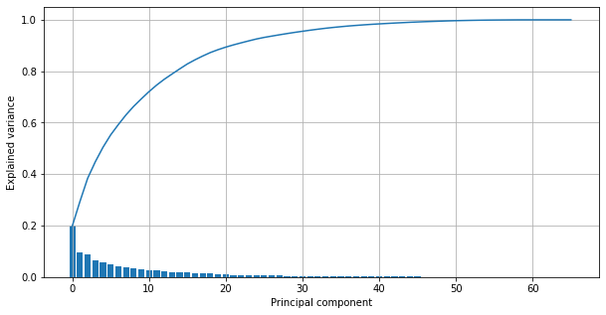
We get a total of 15 features that help us account for 80% of the variance. We stay at the 80% level in order to prevent overfitting the model.

Additionally we consider all of the components including the price of the previous time point to predict the price of the current time point.

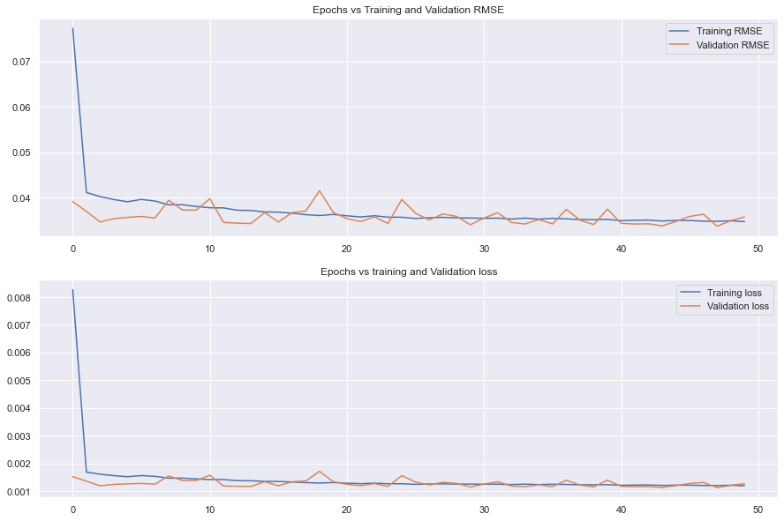
Running the above model we are able to predict the price within an error margin of 3.69 Euro / MWh.

Recommendations and Further Research

A few recommendations for key stakeholders
Some key takeaways-

- Based on the Autocorrelation model - it appears that the price is affected primarily by the immediate two previous data points and the price points lagging by 24. That is the day before. This indicates a pattern or variation on a daily basis.
- Weather features and information such as generation and load also play an important role in the price variation. This aspect can be explored further.

Further Research
- In our univariate LSTM model we considered up to 12 previous data points for fitting the model. Further research can include extending the number of previous data points to 24.

- Likewise in the multivariate analysis, we can extend the number of previous time steps to up 12 and 24 and see the effect on the price prediction.

